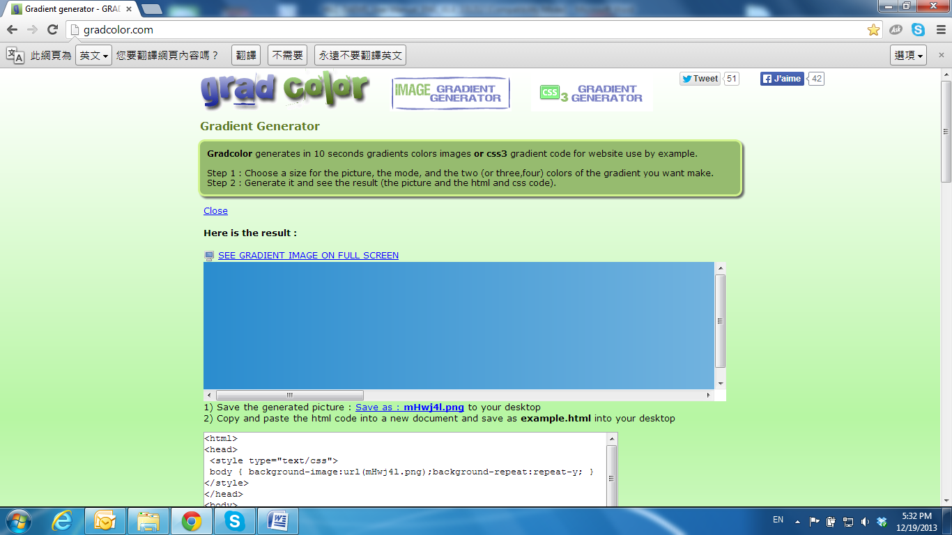

Live Video

Start an IE browser, type the IP address of the IP camera in the address field. It will show the following dialogue box. Key-in the user name: **admin** and password: **admin**.

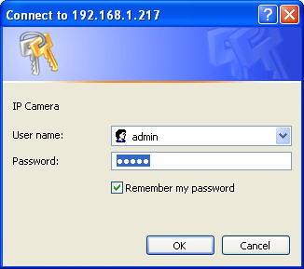

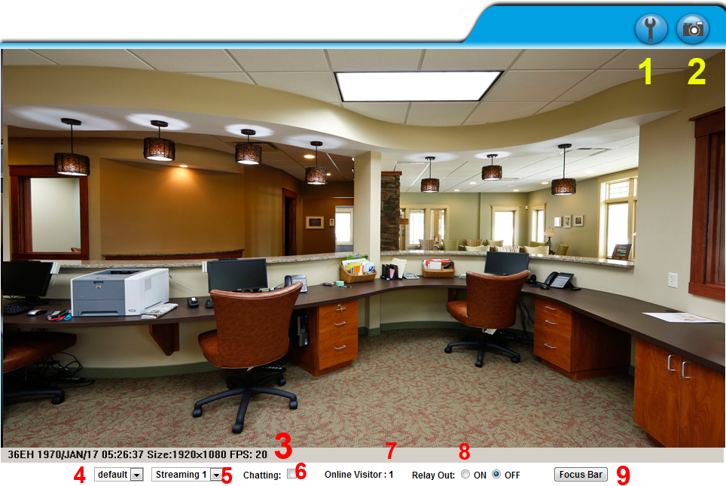When the IP Camera is successfully connected it shows the following interface.

1. Get into the administration page.
2. Video Snapshot.
3. Show the system time, video resolution, and video refreshing rate.
4. Adjust image: 1/2x, 1x, 2x.
5. Streaming source: If the streaming 2 is closed, this function will not be displayed.
6. Tick on **Chatting** for enabling two-way audio.
7. Shows how many people are connected to this IP camera.
8. Control the relay output connected to this camera.
9. Focus bar: It will display a focus bar in the top-left corner, on the live video image for 3 minutes. The bar will be displayed as full if the camera is totally focused towards the objective.

Double-clicking on the video will change the view to full screen mode. Press **Esc** or double-click the video again for changing back to normal mode.

Right-Click the mouse on the video, it will show a pop-up menu.

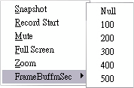

1. Snapshot: Save a JPEG picture.
2. Record Start: Record the video in the local PC. It will ask where to save the video. To stop recording, right-click again and Select **Record Stop**.

The video format is AVI. Use Microsoft Media Player to play the recorded file.

1. Mute: Turn-off the audio. Click again to turn on it.
2. Full Screen: Full-screen mode.
3. Zoom: Enable the zoom-in and zoom-out functions. First, select **Enable digital zoom** option within the pop-up dialogue box and then drag and drop the bar to adjust the zoom factors.

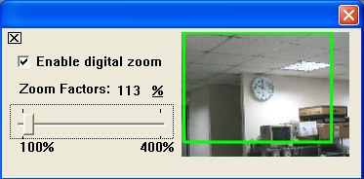

1. Frame Buffm Sec: This function builds a temporary buffm to accumulate several video frames. This function can make video smooth-going when the Network speed is slow and lag. If you select **100**, the camera plays video 100 mSec after receiving images from camera. The slower the Network is the bigger value should be selected. The available values are: **NULL, 100, 200, 300, 400, and 500**. The default value is null.